

**SAMAR STATE UNIVERSITY**

Arteche Blvd., Catbalogan City, Philippines 6700

**College of Engineering**

Ultrasonic Wave Characteristics of the HC – SRO4: A Study on Frequency, Spectrum, and Propagation Time

Case Study Proposal

Engr. Rojay A. Flores

**Subject Teacher**

Babon, Jay Laureen A.

Silagan, Syrelle P.

Ocenada, John Carlo M.

1. **INTRODUCTION**

Distance measurement is vital in many applications like robotics, automation, and security systems. The HC-SR04 is a popular ultrasonic sensor used for non-contact distance measurements. This sensor operates by emitting an ultrasonic sound pulse and measuring the time it takes for the echo to return to calculate the distance to an object.

The HC-SR04 ultrasonic sensor is widely used for distance measurement in various applications. Its performance depends on factors such as frequency, signal spectrum, and duration, which may change based on the measured distance.

This case study focuses on observing the characteristics of the HC-SR04 sensor, including its input and output frequency, spectral properties, and signal duration at distances ranging from 5 cm to 50 cm in 5 cm increments. The goal is to understand how these parameters behave under different conditions and provide insights into the sensor’s operation.

1. **MATERIALS USED**
2. **HC-SR04 Ultrasonic Sensor**

* Used for measuring distances by emitting ultrasonic waves and capturing their echoes.

**System Design**

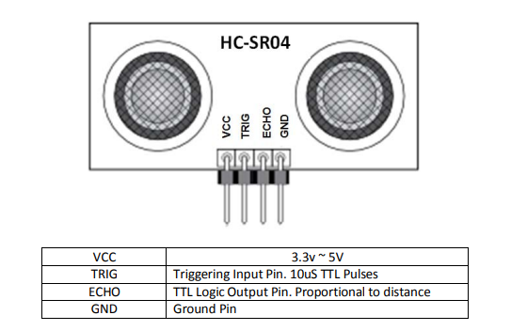

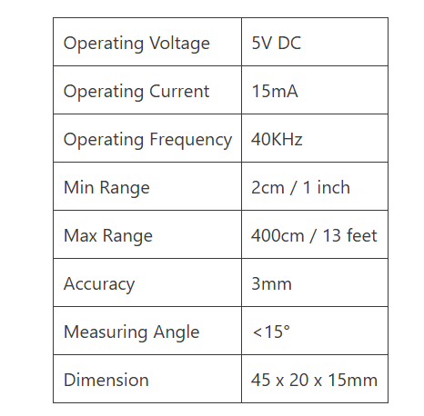**Specification**

1. **Arduino**

* A microcontroller platform for generating trigger pulses, reading echo signals, and communicating data to a computer.

1. **Analog Discovery 3**

* A multifunctional test and measurement device used for signal monitoring and analysis.

1. **Waveform Software**

* Software interface for the Analog Discovery 3, enabling real-time waveform capture and frequency analysis.

1. **Flat Wood**

* A long, flat, rectangular piece of wood.

1. **Ruler**

* Ensure precise and consistent placement of the sensor and surfaces.

1. **Wiring and Breadboard Components**

* Breadboard, jumper wires, and resistors for making electrical connections between the Arduino Uno and HC-SR04 sensor.

1. **Soldering Iron**

* A hand tool used in soldering.

1. **Soldering Lead**

* A metal alloy usually made of tin and lead which is melted using a Soldering iron.

1. **Laptop**

* For programming the Arduino Uno, interfacing with the Analog Discovery 3, and analyzing data using WaveForms software.

1. **PROCEDURE**

**Preparation of Materials**

The materials required for the experiment are:

1. HC-SR04 Ultrasonic Sensor – For measuring distances.
2. Arduino – To control the sensor and collect data.
3. Breadboard – Used for prototyping and testing electronic circuits.
4. Jumper Wires – Used to connect different components in a circuit.
5. Flat wood – Used as the reference surface in this study.
6. Soldering Iron – Used for soldering the transducers of ultrasonic sensor.
7. Soldering Lead – Used to connect the wire and terminal of the transducers
8. Ruler – To ensure accurate measurement of distance.
9. Analog Discovery 3 – For recording and analyzing the signals.
10. Waveform Software – To display and store signal data.
11. Laptop – To run software and the Arduino.
12. Arduino IDE – For programming and testing the Arduino setup.

**System Setup**

1. Connect the HC-SR04 sensor to the Arduino:
   * VCC: Connect to 5V on the Arduino.
   * GND: Connect to GND on the Arduino.
   * Trig Pin: Connect to a digital output pin.
   * Echo Pin: Connect to a digital input pin.

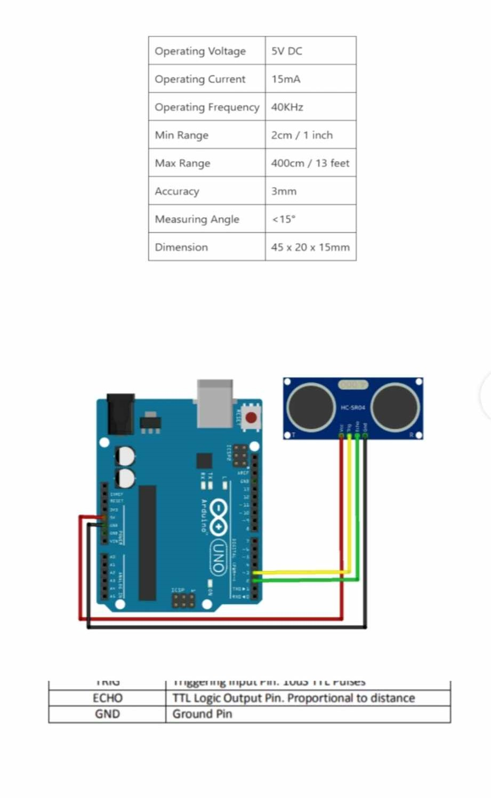

1. Solder the positive Trig Transducer using jumper wire.
2. Solder the positive Echo Transducer using jumper wire
3. Connect the HC-SR04 to Analog Discovery 3

* Positive Trig Transducer: Connect to a Scope Ch.1 Positive
* Positive Echo Transducer: Connect to a Scope Ch. 2 Positive
* GND: Connect to GND on the Analog Discovery

1. Install and set up Waveform Software to display and analyze the signal from the sensor.
2. Load a program onto the Arduino using Arduino IDE to calculate the echo frequency and time propagation.

**Program Code**

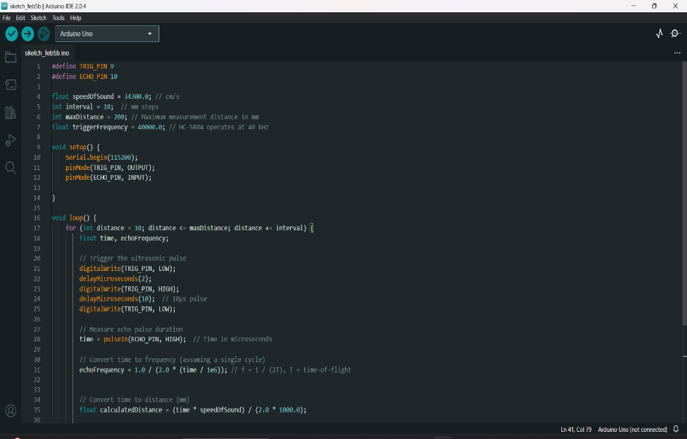

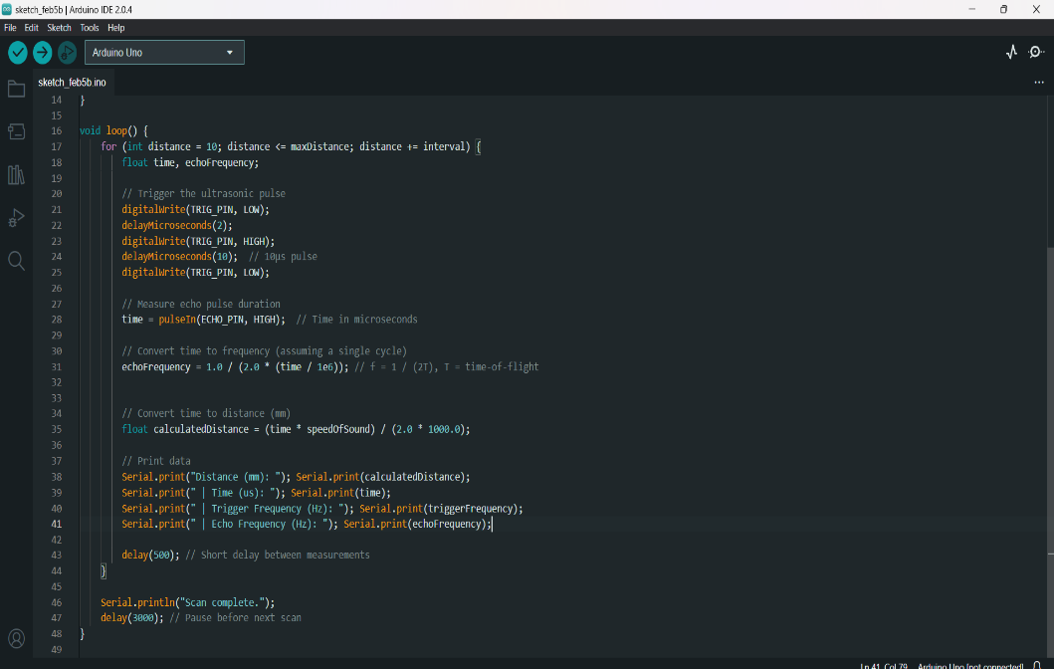

**● Calibration**

1. Place the HC-SR04 in a flat surface at a fixed position.

2. Indicate the distances from 5 cm to 50 cm incremented by 5 cm.

**● Data Collection**

1. Setup for Measurement

* Use a single flat wood surface.
* Ensure that the surface is perpendicular to the sensor to avoid signal reflection errors.

2. Varying Distances

* Position the surface at multiple distances from the sensor starting from 5 cm up to 50 cm.
* Maintain stable and consistent alignment at each distance to minimize measurement errors.

3. Waveform Capture

* Connect the positive Echo Transducer to Scope Ch. 2 to the Analog Discovery 3
* Use waveforms software to capture and visualize the ultrasonic wave’s release and return signals.
* Ensure each waveform capture records both amplitude and frequency of the trig and echo signal.

4. Repeat and Evaluate

* Repeat the process for all specified distances.
* Evaluate the relationship between the echo duration and waveform data to determine the sensor’s performance.

**● Frequency Determination**

1. Evaluate Consistency across Distances

* Record variations in signal characteristics such as duration, frequency and amplitude for each distance.
* Study echo signal’s consistency at varying distances.

2. Explore Frequency Response across Distances

* Find out if the distance affects the frequency response or the amplitude of the echo signal.
* Use the waveform software to analyze the signal’s waveform for each distance.

**● Amplitude Determination**

* Evaluate the amplitude of the echo signal at each distance.
* Determine if the signal strength decreases with increasing distance.

**● Duration Determination**

* Measure the echo duration (time between signal release and return).

1. **RESULT**

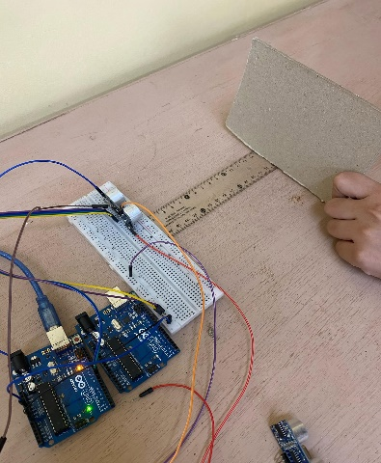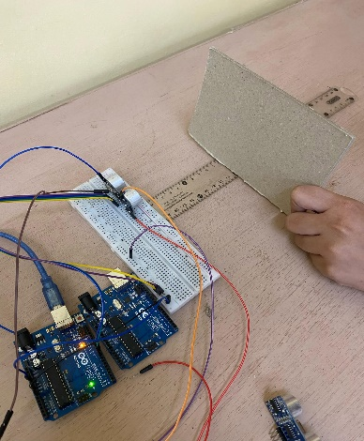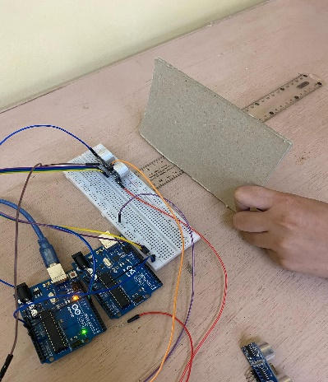 5 cm 10 cm 15 cm

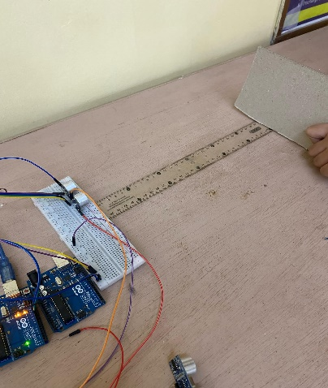 20 cm 25 cm 30 cm

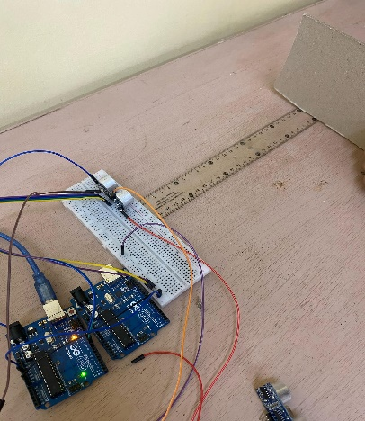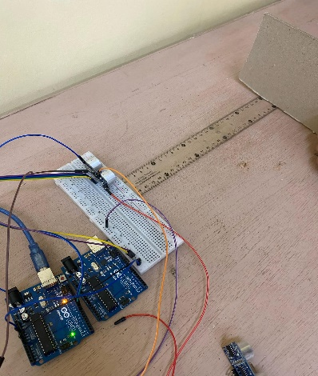

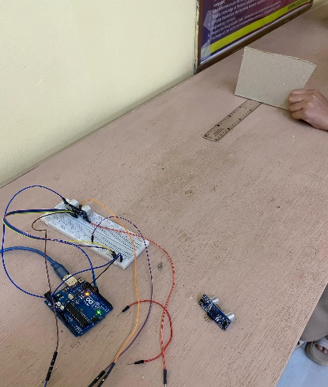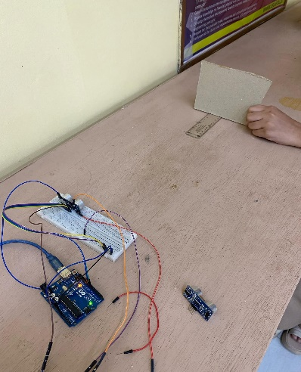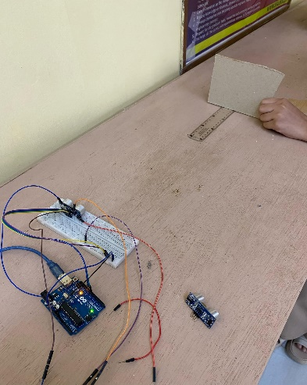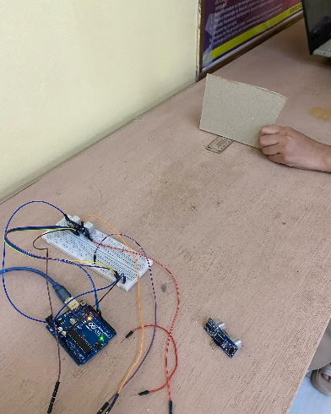35 cm 40 cm 45 cm 50 cm

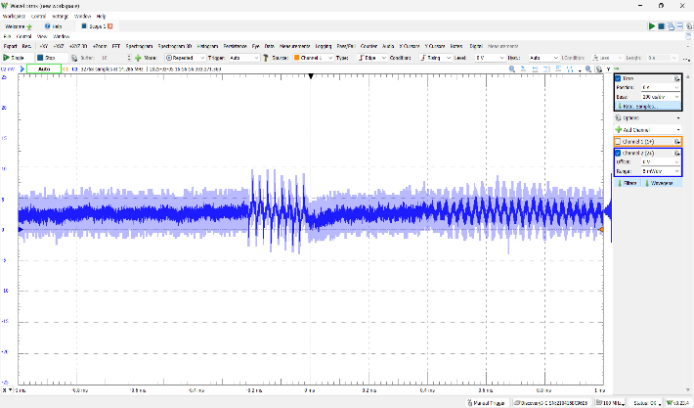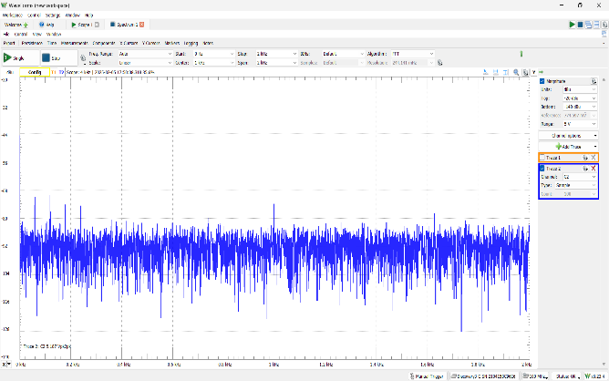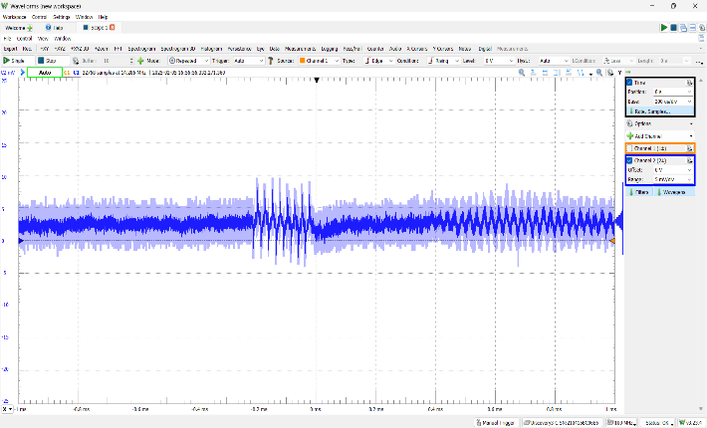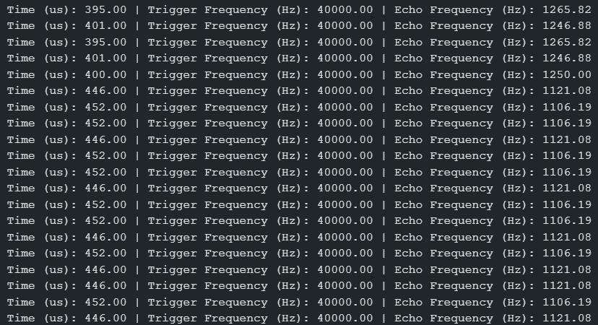Data from a 5 cm distance

The obtained output from a 5 cm distance providing with 20 samples shows that we gained an average 436.5 us in its time duration and 1149 Hz for its echo frequency.

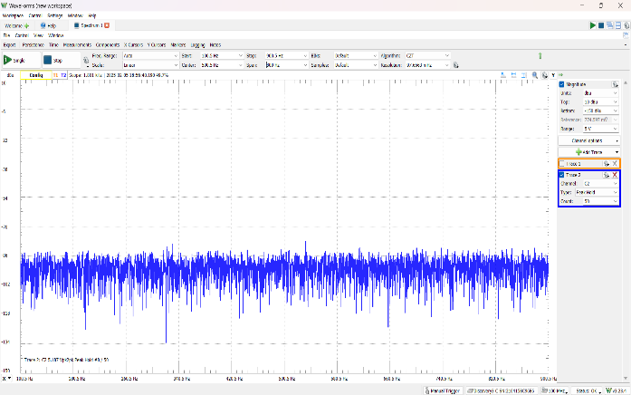Data from a 10 cm distance

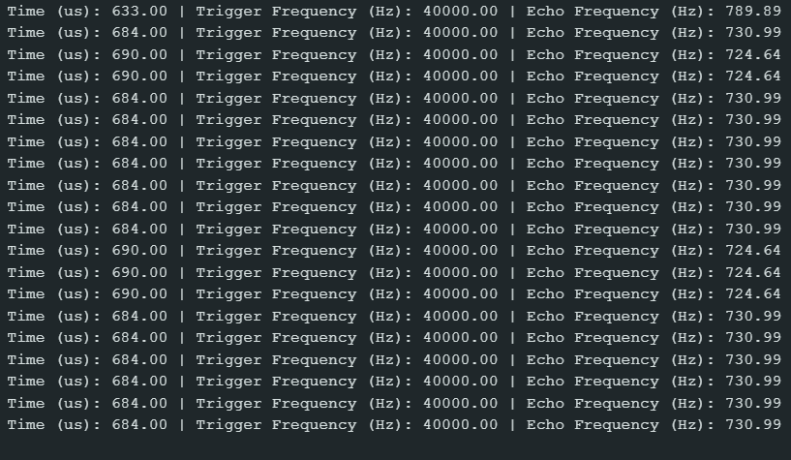

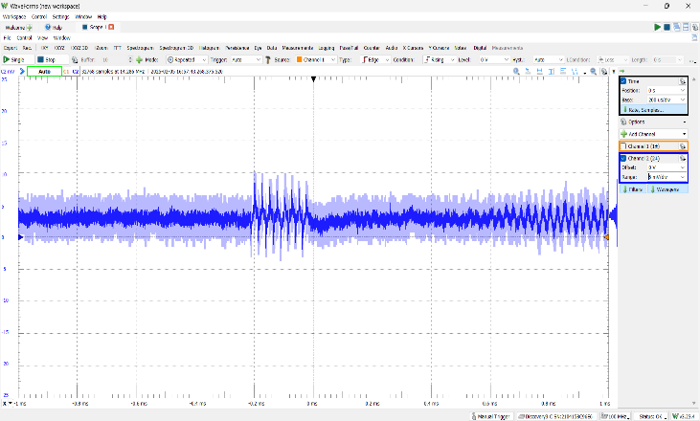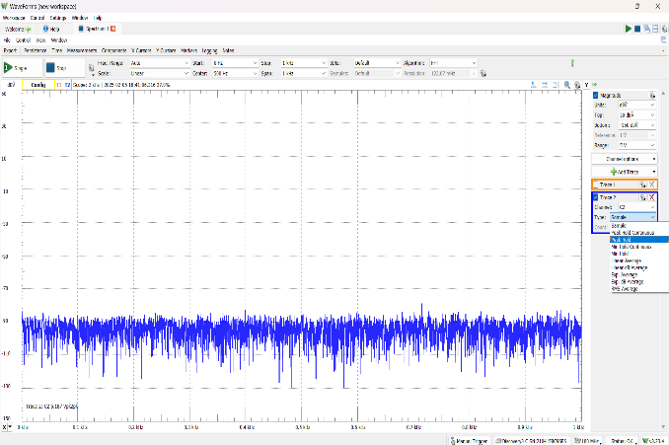

The obtained output from a 10 cm distance providing with 20 samples shows that we gained an average 683 us in its time duration and 732 Hz for its echo frequency.

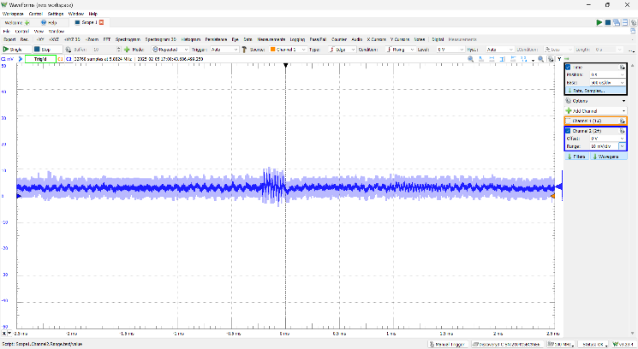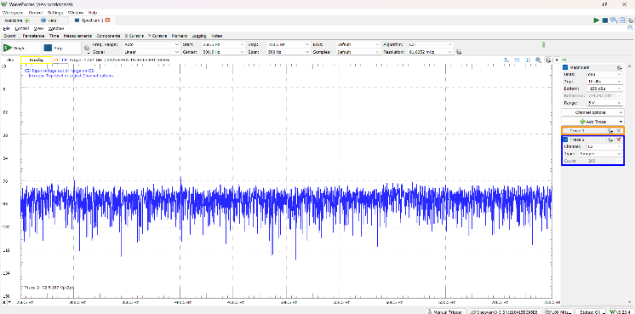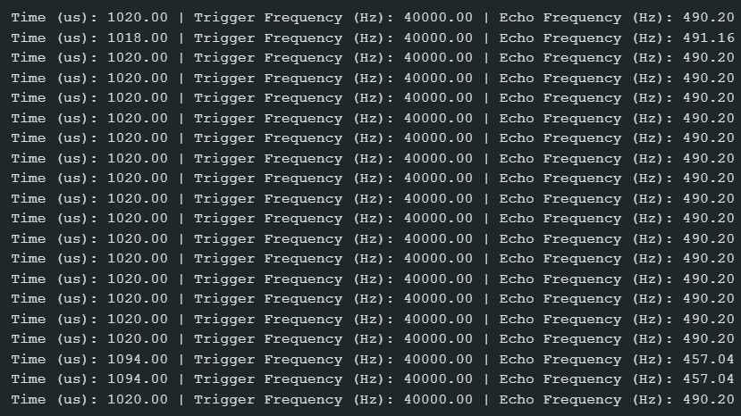Data from a 15 cm distance

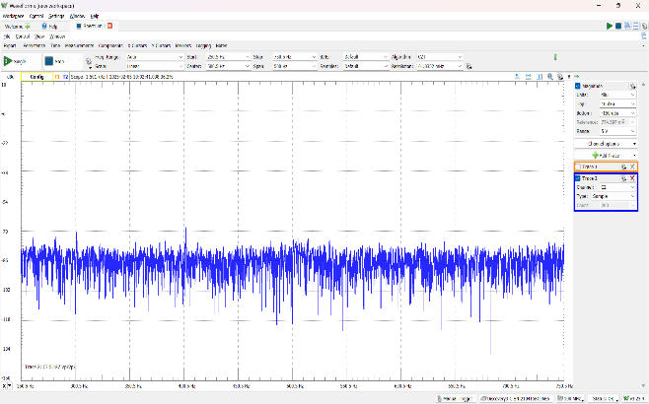

The obtained output from a 15 cm distance providing with 20 samples shows that we gained an average 1027 us in its time duration and 487 Hz for its echo frequency.

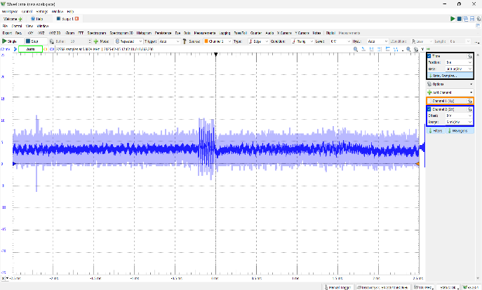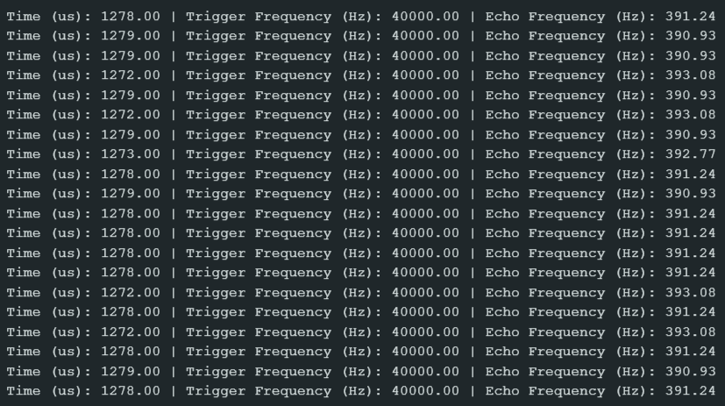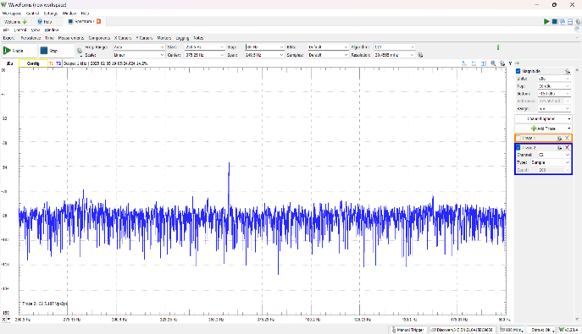Data from a 20 cm distance

The obtained output from a 20 cm distance providing with 20 samples shows that we gained an average 1277 us in its time duration and 391.6 Hz for its echo frequency.

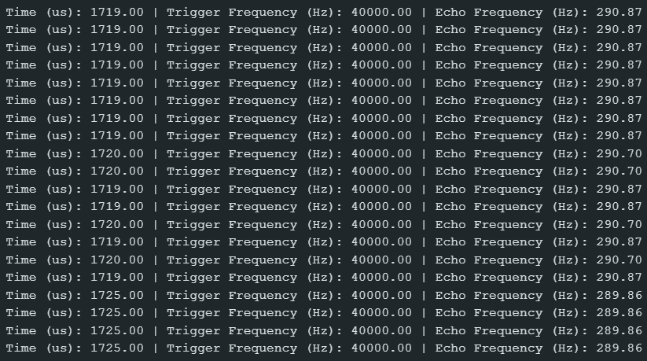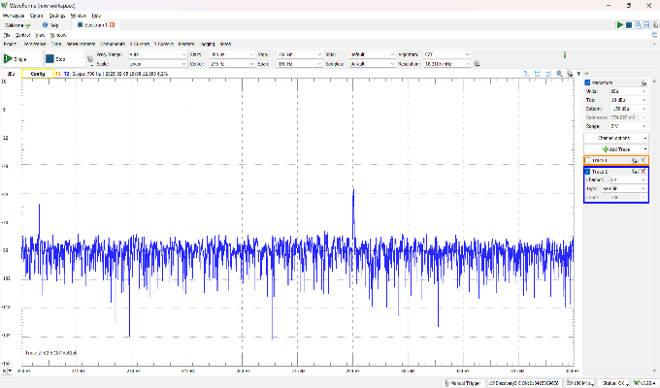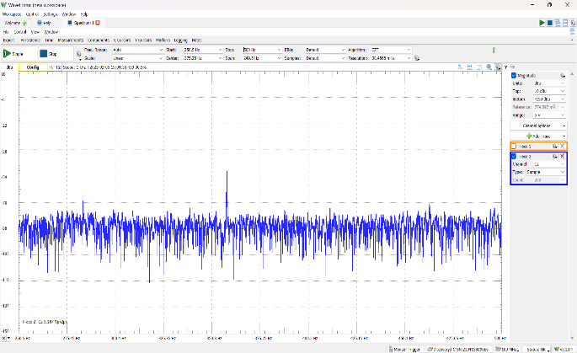Data from a 25 cm distance

The obtained output from a 25 cm distance providing with 20 samples shows that we gained an average 1634 us in its time duration and 290.6 Hz for its echo frequency.

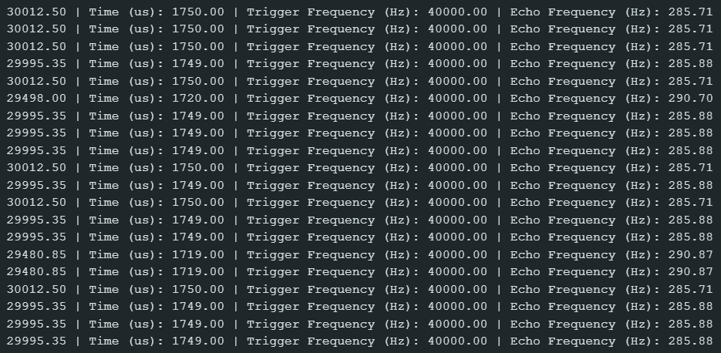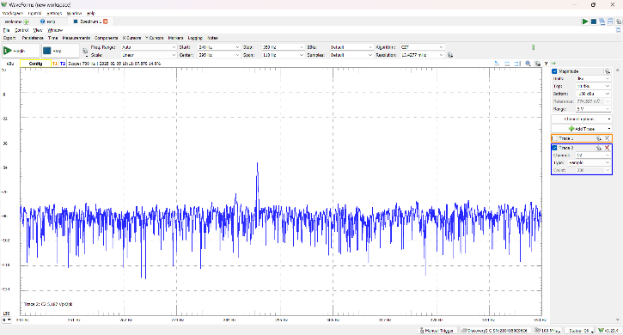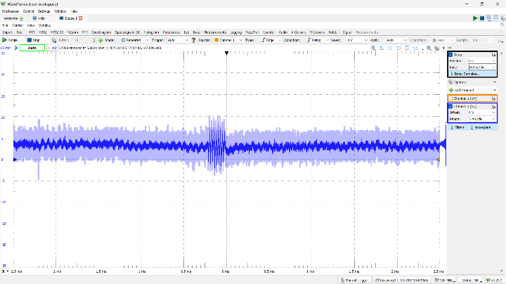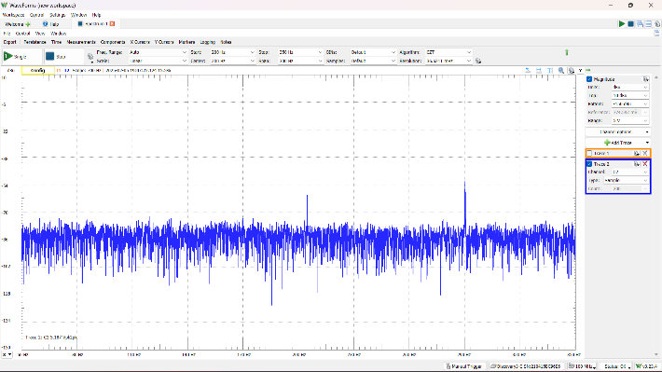Data from a 30 cm distance

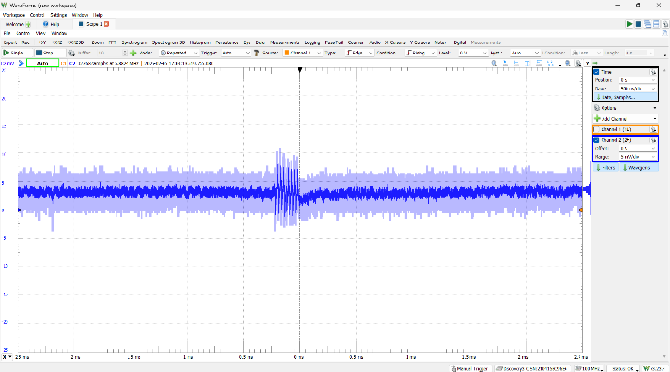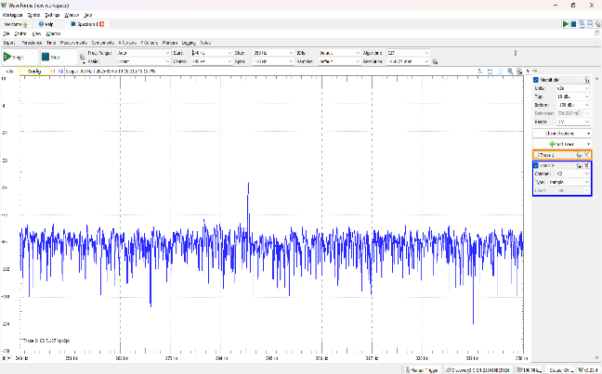

The obtained output from a 30 cm distance providing with 20 samples shows that we gained an average 1750 us in its time duration and 286.6 Hz for its echo frequency.

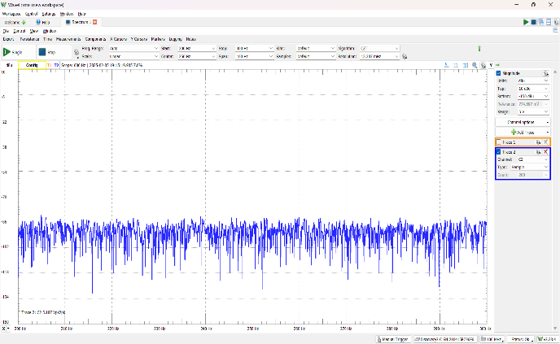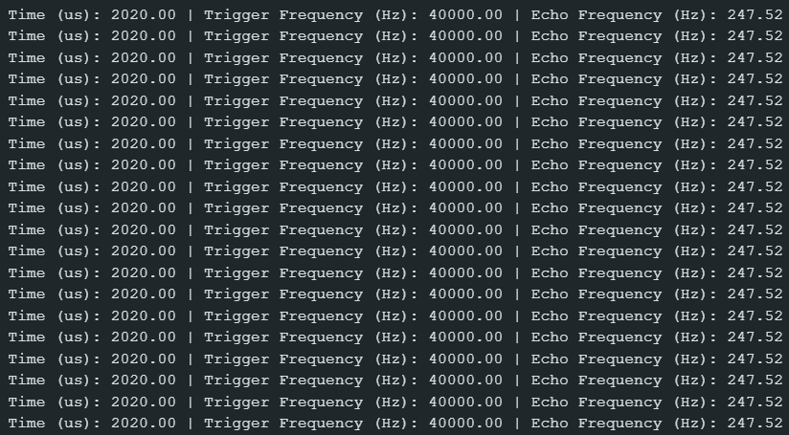Data from a 35 cm distance

The obtained output from a 35 cm distance providing with 20 samples shows that we gained an average 2020 us in its time duration and 247.5 Hz for its echo frequency.

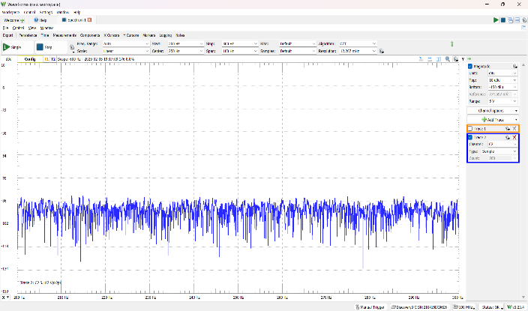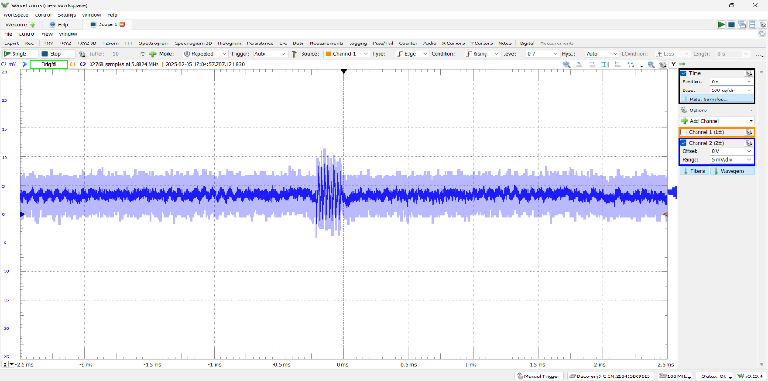Data from a 40 cm distance

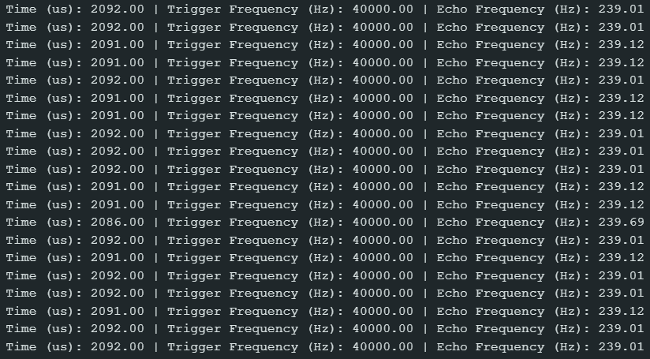

The obtained output from a 40 cm distance providing with 20 samples shows that we gained an average 2091 us in its time duration and 239 Hz for its echo frequency.

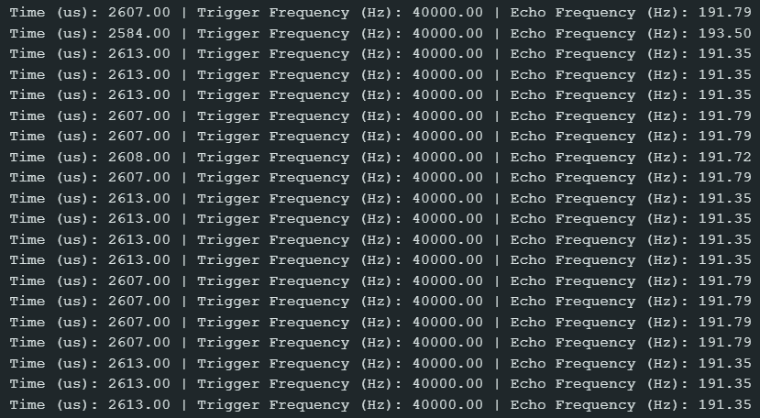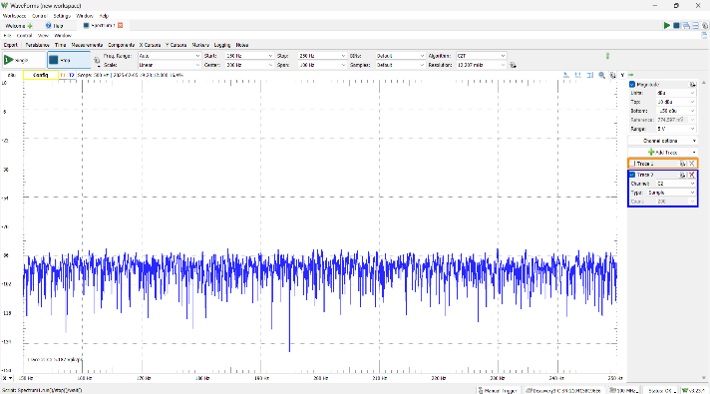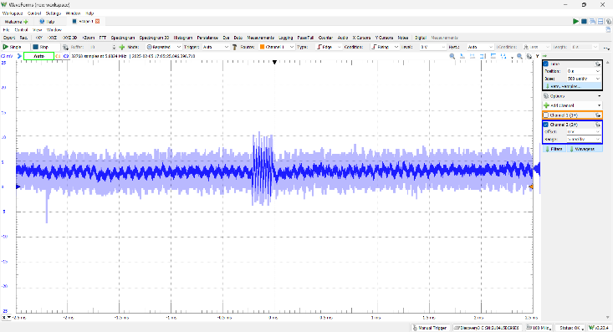Data from a 45 cm distance

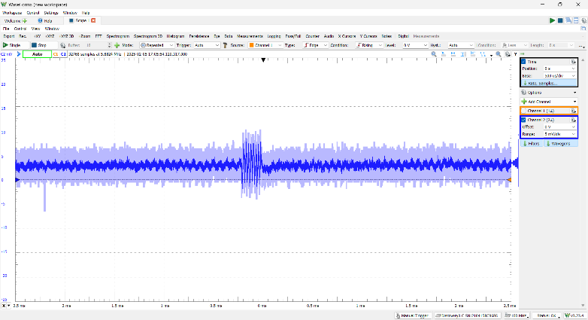

The obtained output from a 45 cm distance providing with 20 samples shows that we gained an average 2609 us in its time duration and 191.7 Hz for its echo frequency.

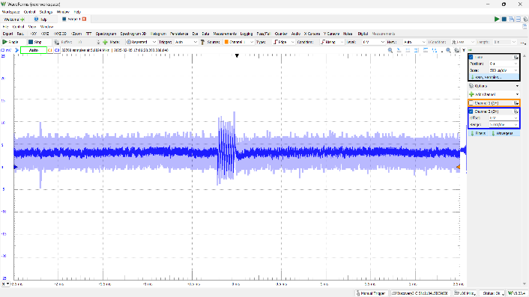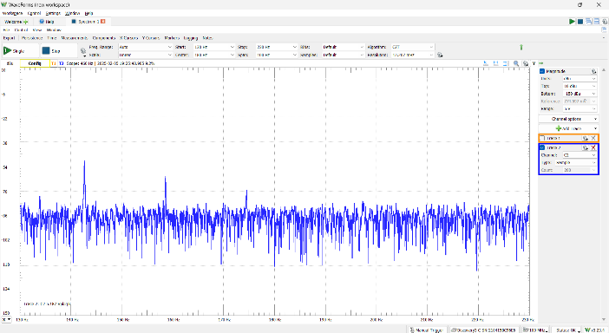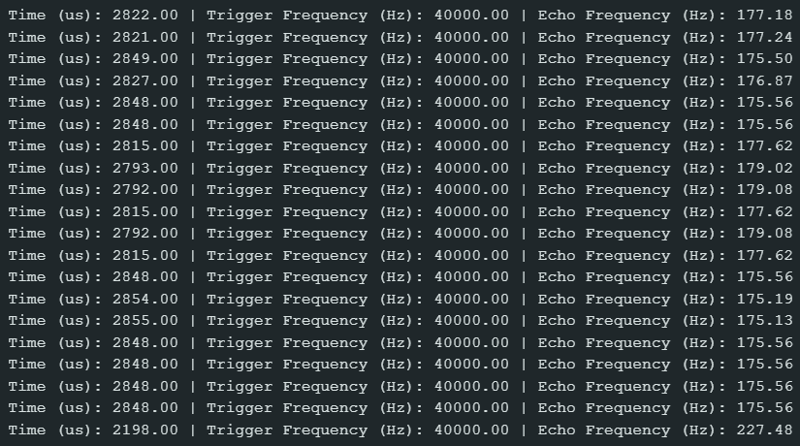Data from a 50 cm distance

The obtained output from a 50 cm distance providing with 20 samples shows that we gained an average 2799 us in its time duration and 179 Hz for its echo frequency.

1. 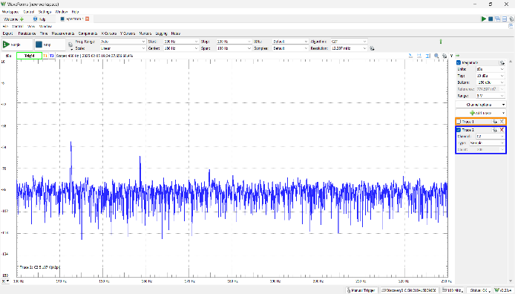**CONCLUSION**

In conclusion, after using wood as the surface, we observed that the results varied depending on the distance. The experiment shows that as the distance increases beyond 30 cm, the results become less distinct, noise has a greater impact, and it becomes more noticeable. As the distance gets bigger, the echo frequency becomes weaker until the waveform can no longer detect it. When the signal gets too weak, only noise can be seen in the readings. This shows that distance is important for accuracy and reliability. The farther the distance, the harder it is to get clear and accurate results, leading to more interference from noise.